Coronary Heart Disease

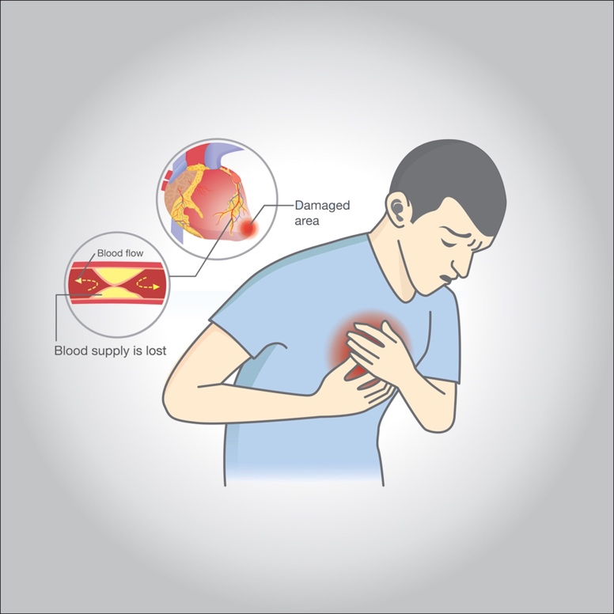

**Coronary artery disease occurs when the main blood vessels that supply your heart are damaged or injured. Coronary artery disease is usually caused by cholesterol-containing deposits (plaques) in the coronary arteries and inflammation. Coronary arteries supply your heart with blood, oxygen, and nutrients**

**Reasons**

**Coronary artery disease occurs when the main blood vessels that supply your heart are damaged or injured. Coronary artery disease is usually caused by cholesterol-containing deposits (plaques) in the coronary arteries and inflammation. Coronary arteries supply your heart with blood, oxygen, and nutrients**

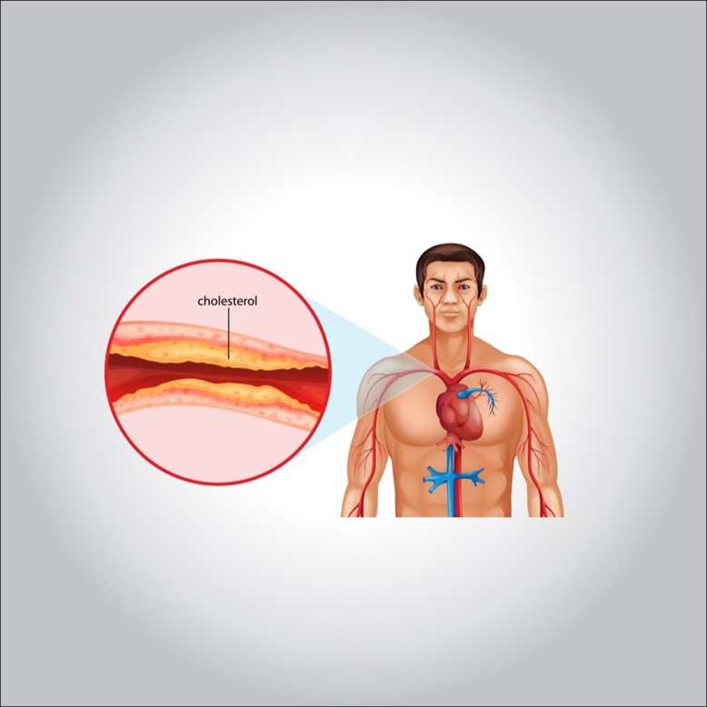

**The main symptoms of coronary artery disease are:**

* **pain in chest.**
* **Choking in the chest (you may feel its symptoms in areas other than the chest, such as: the shoulder, arms, neck, back and jaw). These are its signs: Feeling of heaviness. The presence of pressure. Intermittent pain; burning sensation of numbness …**
* **shortness of breath.**
* **Irregular heartbeat.**
* **General weakness and dizziness.**

**Protection**

* **Quit Smoking.**
* **Control of medical conditions such as high blood pressure, high cholesterol, and diabetes.**
* **Maintain your physical activity.**
* **A diet low in salt, low in fat, and rich in fruits, vegetables, and whole grains.**
* **Maintain a healthy weight.**
* **Reducing and controlling stress**

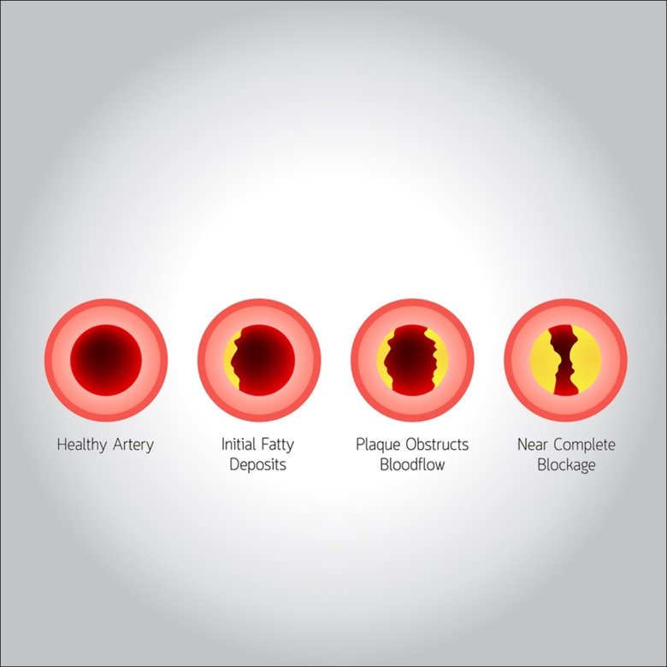

**Treatment or treatment**

**Many drugs can be used to treat coronary artery disease, including Cholesterol-modifying drugs. These medications reduce (or modify) the essential substance that deposits in the coronary arteries. As a result, cholesterol levels decrease, especially low-density lipoprotein (LDL or “bad”) cholesterol.**